STUDENT WORKSHEET
Making Topographic Maps
Geologists and geographers use topographic maps (of the land surface) and bathymetric maps (of the ocean floor) to understand the three dimensional structure of Earth. Contour maps show a view of the terrain from above and can be translated to an elevation profile to show the shape of the land as seen from the ground.
While scientists do some mapping from the ground, much of the data collected for these maps comes from instruments built by engineers for use aboard spacecraft, aircraft, and ships. These instruments collect data by sending light or sound waves with a known speed to the surface and measuring the time it takes for them to reflect or bounce back.
Directions
- Below, several contour maps are provided with two cross sections: X-X’ and Y-Y’. These are paths we’ll use to create our elevation profiles, as if we were walking in a line from one end to the other. Each curved contour line on the map illustrates where the elevation changes. The map has a specified elevation interval displayed in the legend, so that geographers can interpret the steepness of a feature by how close or far apart the contour lines are. Each time you pass over a contour line along the cross section, the elevation changes by the map interval.
- On the first three contour maps below, align a sheet of paper on the X-X’ cross section line.
- Moving from left to right, mark on your sheet of paper each time you encounter a change in elevation (cross a contour line).
- Take your sheet of paper and line it up within the blank elevation profile provided. Each of the marks you made represents a coordinate on this graph, with a horizontal distance (x axis) and a height at that contour (y axis). Plot each point at the spot where these measurements cross.
- Now connect your dots to get an elevation profile of that feature as seen from the ground.
- Repeat the steps from top to bottom using the Y-Y’ cross section line.
- Lastly, put your knowledge to the test by answering the questions about the fourth, more complicated map.

Contour Map 1
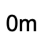
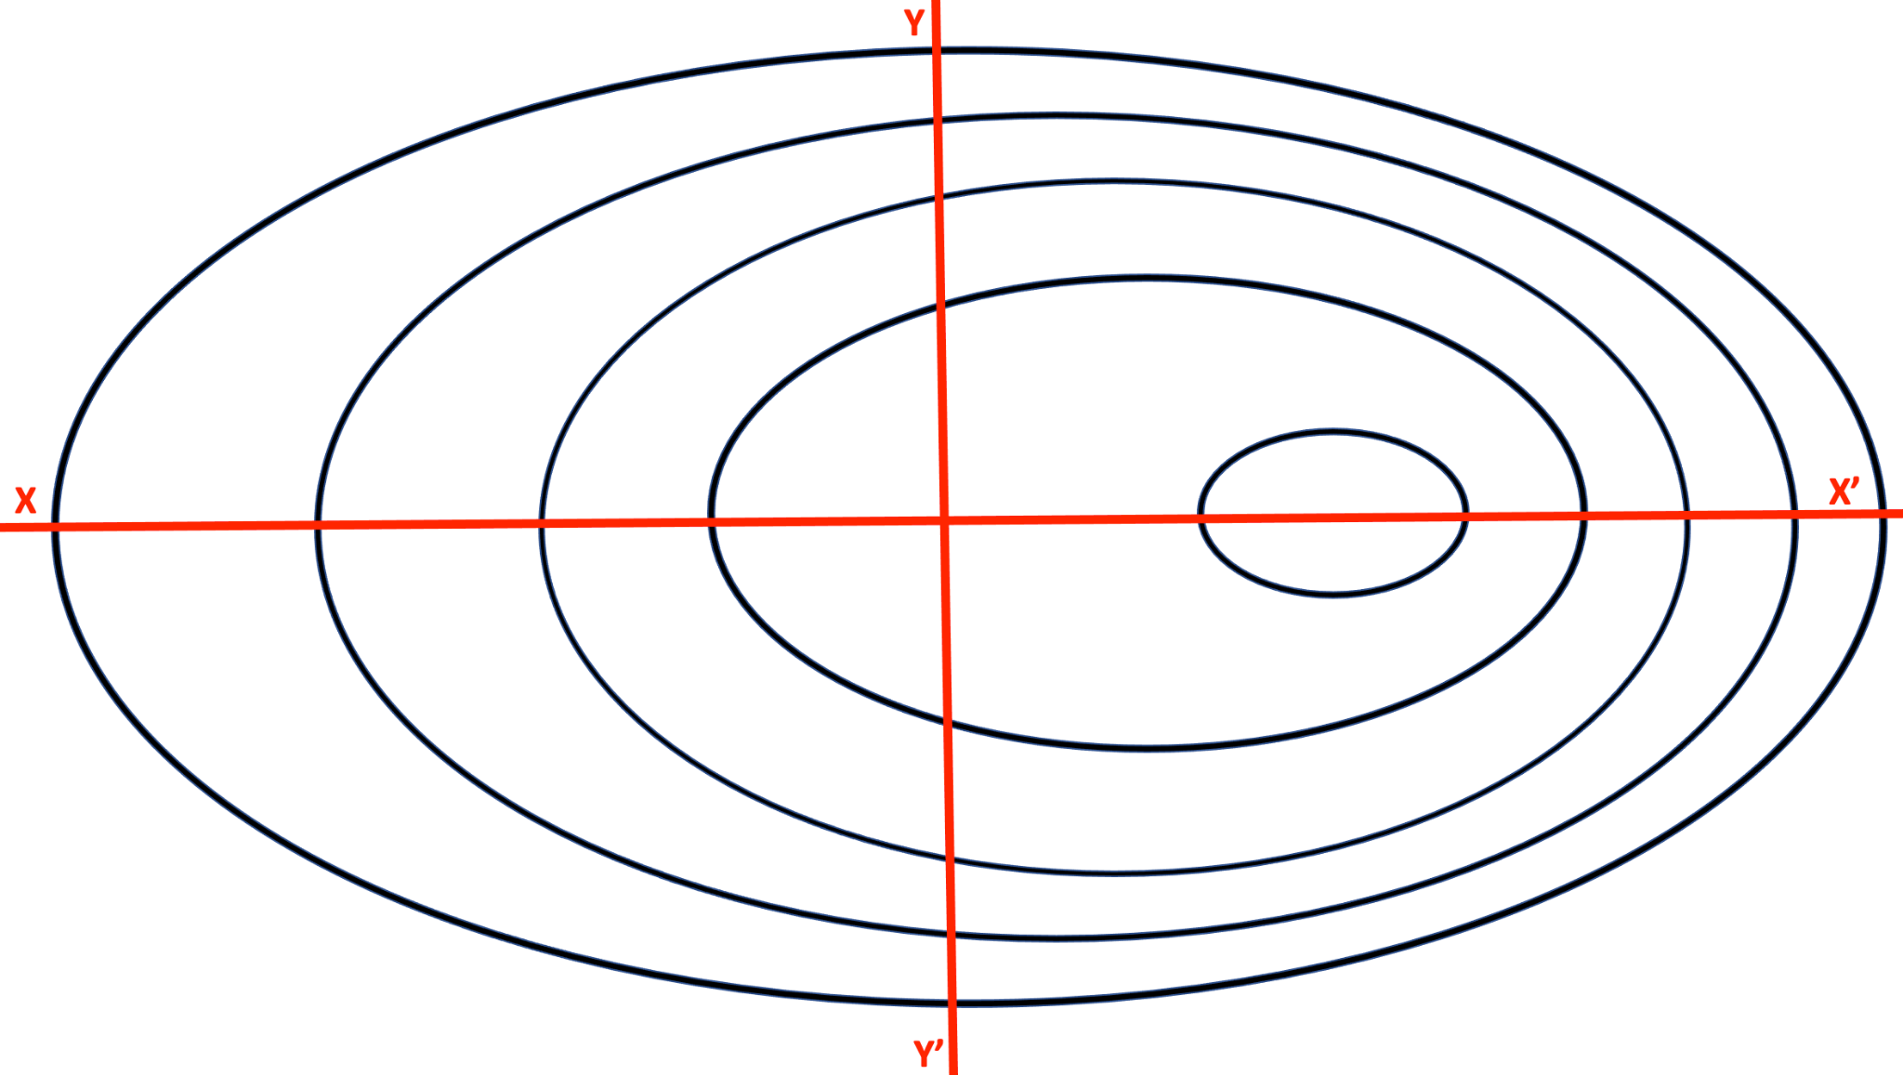
Contour Line Interval: 40m

Elevation Profile 1
X-X’
Y-Y’
Contour Map 2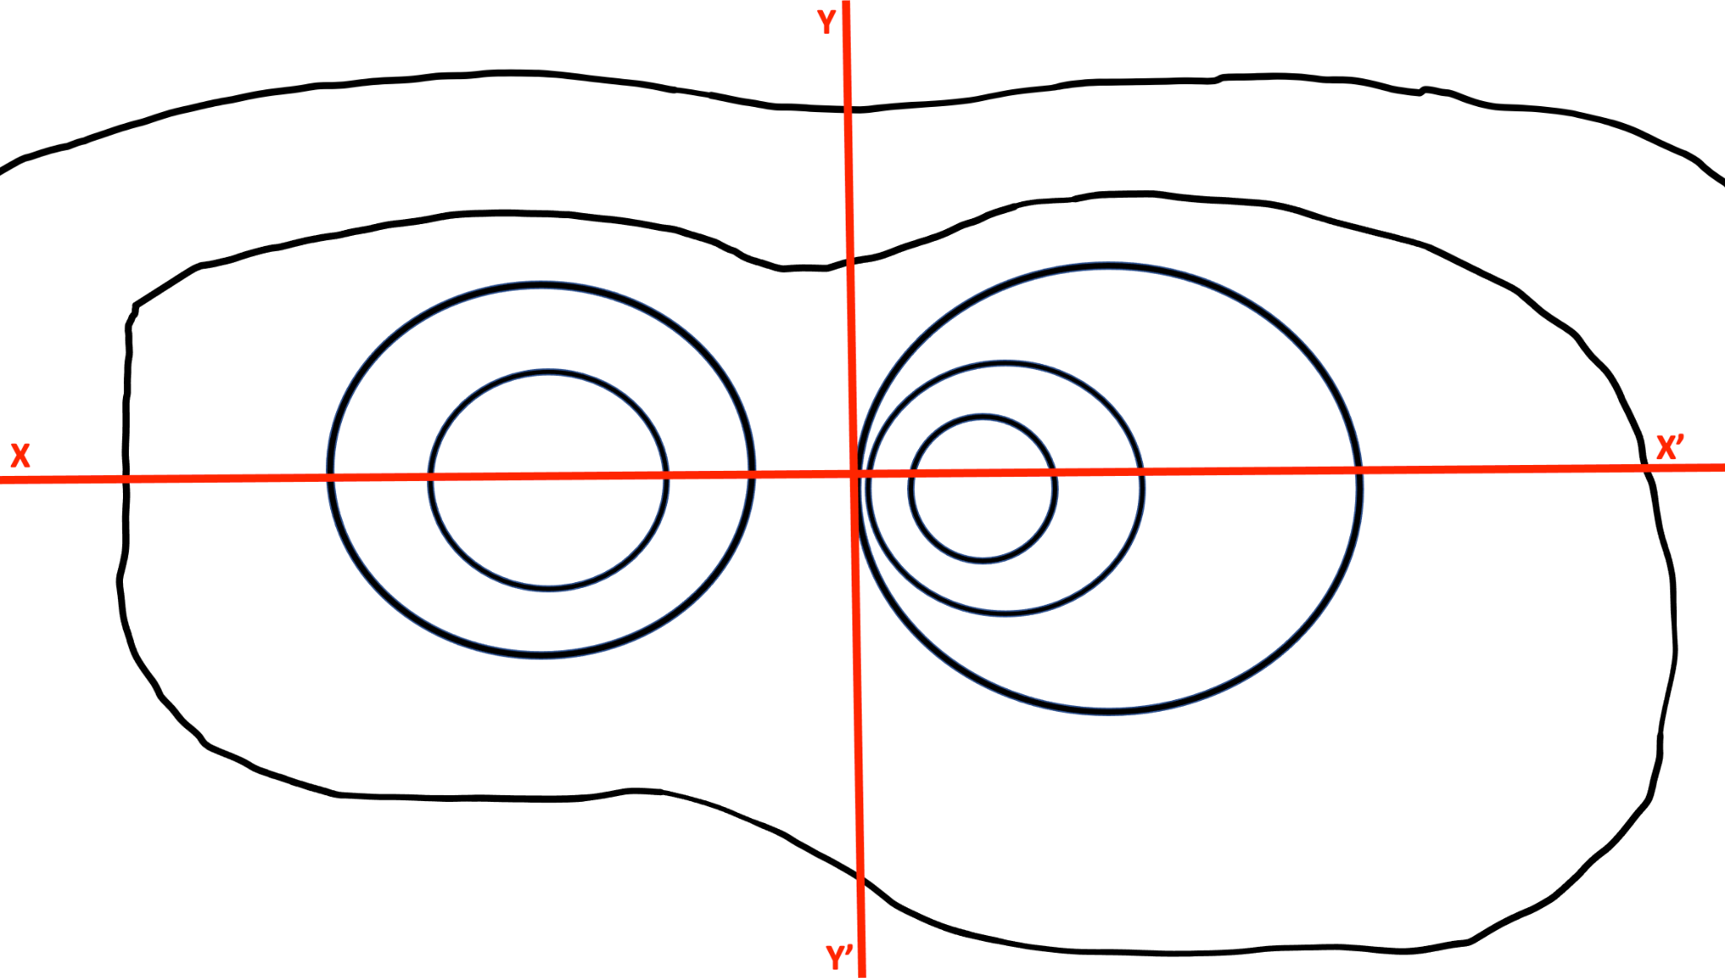
Contour Line Interval: 100m
Elevation Profile 2
X-X’
Y-Y’
Contour Map 3
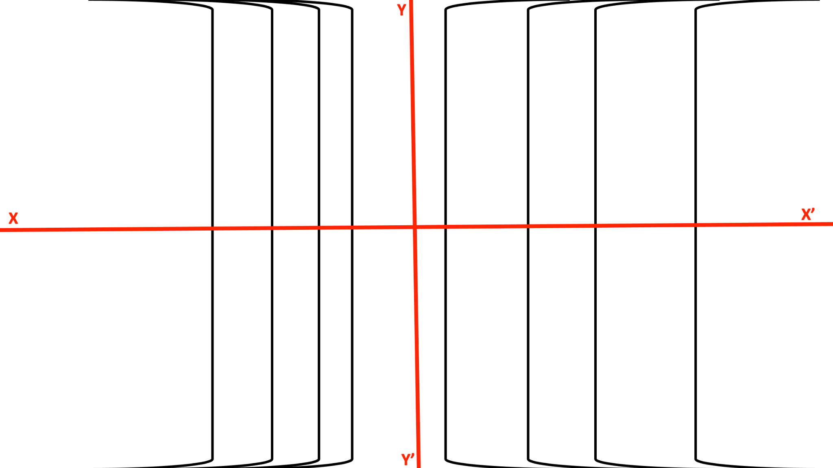
Contour Line Interval: 30m

Elevation Profile 3
X-X’
Y-Y’

Advanced map
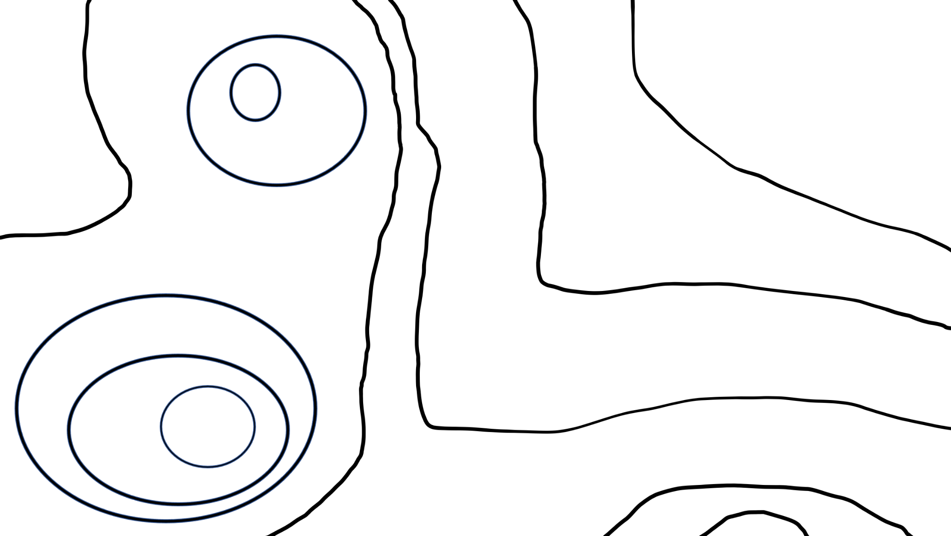
Contour Line: 10m
- Using the zero heights as references, add the rest of the heights above or below sea level on the contour lines.
- On the map, draw a line for how you would expect water to flow from position A into the water nearby.
- If you were to select a line to draw your elevation profile as you did in the maps above, where would you put it? Draw an X-X’ on your map. What features did you capture and what does your choice leave out?

