STUDENT WORKSHEET

Calculating Solar Power in Space
Understanding how much sunlight a spacecraft is receiving, and by extension how much energy the solar panels can generate at any point on its journey is vital to mission success and as simple as understanding division and exponents. We use these math concepts to describe a relationship between Earth, the sun and the spacecraft in a law known as the inverse square law.
The inverse square law is expressed as $\frac{1}{d^{2}}$ where d equals distance in astronomical units (AU) to the spacecraft as compared with Earth’s distance to the Sun. An astronomical unit is the average distance between Earth and the Sun – about 149.6 million kilometers. The inverse square law tells us how much energy is received at any point compared to a reference point. In this case, the reference point is Earth.
Spacecraft at … | Distance (d) astronomical units | $\frac{1}{d^{2}}$ | Percent of energy  received | Watts per square meter available
Earth | 1.00 |  |  | 1360.8  w/m²
Mars | 1.52
Ceres  (asteroid belt) | 2.77
Psyche  (asteroid belt) | 3.3
Jupiter (at farthest distance from sun) | 5.37

Spacecraft can have massive solar panels. However, they do not turn 100% of the available energy into power for the spacecraft. If a spacecraft with 55.5 m² of active solar cells was able to convert 28% of the energy that falls on them into usable power, how much power could they potentially generate at each of the locations named above?
 | Earth | Mars | Ceres | Psyche | Jupiter
Power generated
(watts)

Testing the Inverse Square Law
1. In a dark room, stand a mobile device upright as close to vertical as you can with the light sensor (typically on the front) facing in the direction of a light source. You may need to brace it with books to keep it perpendicular to the surface.
2. Open the lux measurement app.
3. Place the mobile device one foot away from the light source and record the lux reading. If you have a second mobile device with an LED light, that can be used as a light source pointing toward the first device with the lux meter app.
SAFETY: LEDs from mobile devices provide an even output of very low temperature light compared to incandescent bulbs. If you use a flashlight and have removed the reflector housing to create an even light source, the exposed bulb can become very hot. Be careful to avoid burns.
4. Based on the one-foot reading, use the inverse square law to calculate what the light reading will be at two, three, four and five feet.
5. Move the mobile device an additional foot away. Record the lux measurement and check to see if the measurement matches your prediction. Because there may be stray light reaching the light sensor, the measurement may not exactly match your prediction.
6. Continue recording light measurements at three, four, five and six feet from the sensor, comparing measurements to predictions.

Sample setup
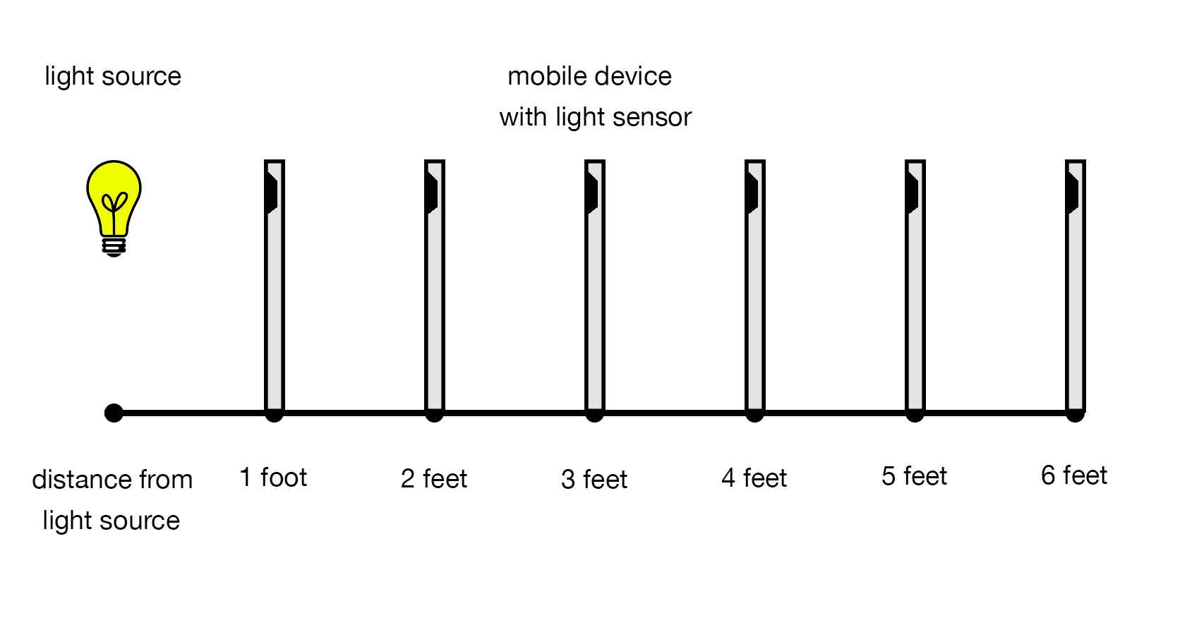
Distance to light source (d) | $\frac{1}{d^{2}}$ | Fraction of energy | Percent of energy | Lux
1 foot |  |  |  | Measured: ______
2 feet |  |  |  | Predicted: _______  Measured: ______
3 feet |  |  |  | Predicted: _______  Measured: ______
4 feet |  |  |  | Predicted: _______  Measured: ______
5 feet |  |  |  | Predicted: _______  Measured: ______
6 feet |  |  |  | Predicted: _______  Measured: ______

