STUDENT WORKSHEET

Make a Soda Can Engine
In this activity, you will experiment with engines by creating a device inspired by the aeolipile (pronounced "ee-oh-li-pile") engine invented by Hero of Alexandria.
Team Member Names:

Design an experiment to increase the number of rotations a soda can engine makes.
Write your experiment hypothesis:

Briefly explain your experiment procedures:
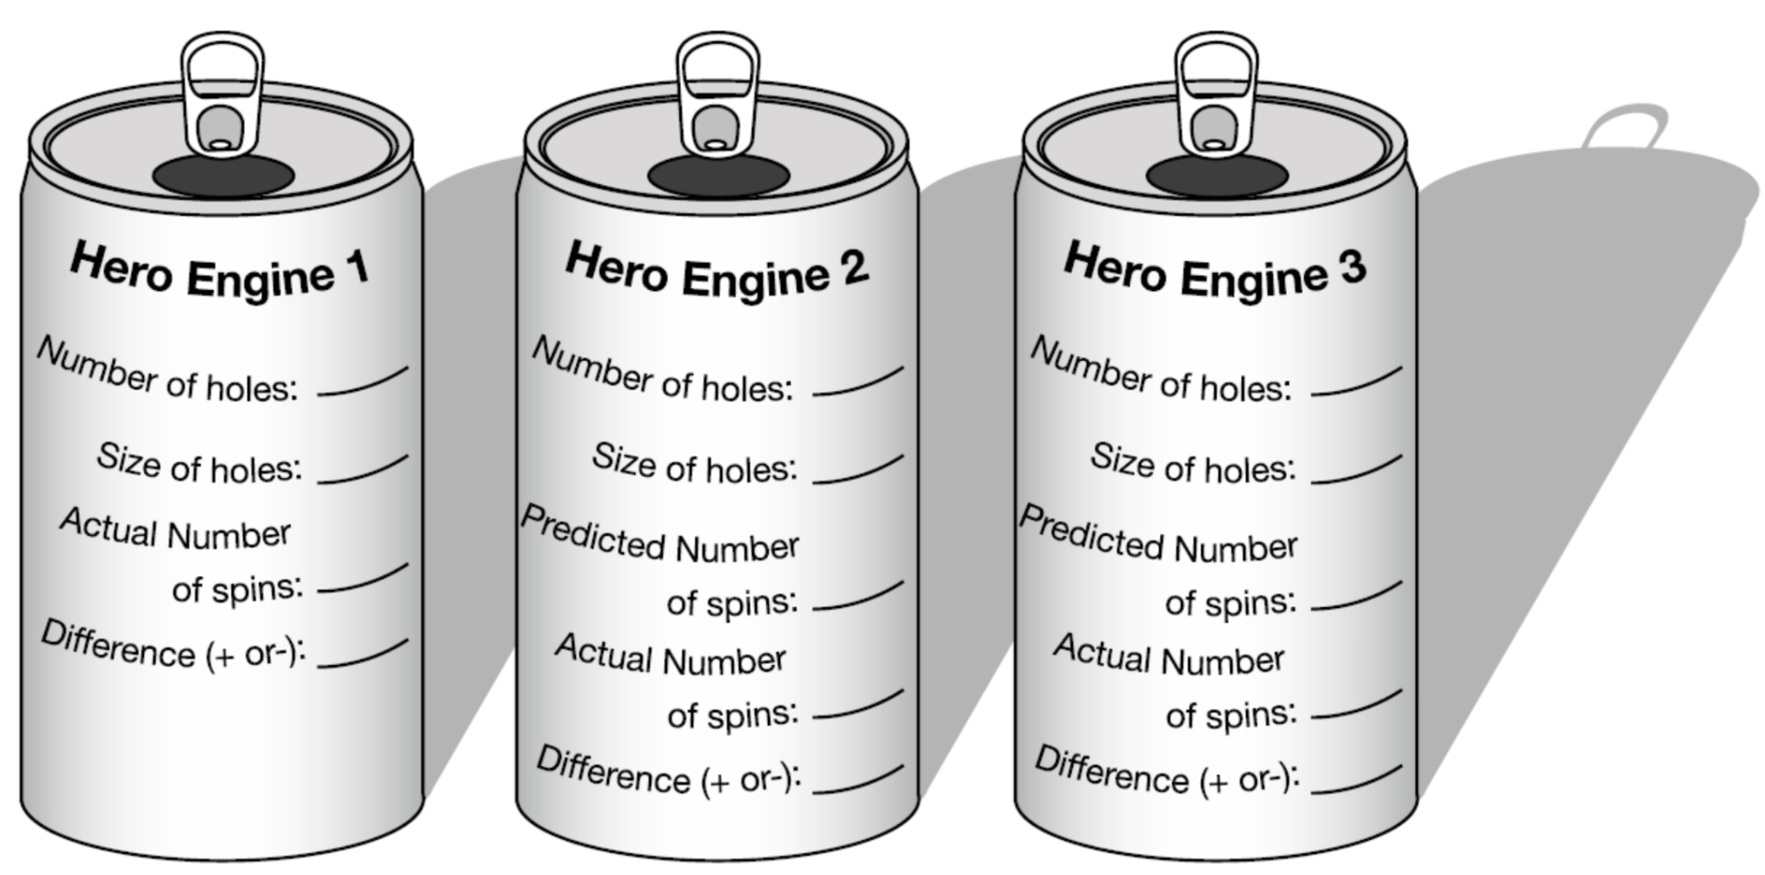

Based on your results, was your hypothesis correct?
Why?

Design and build a new soda can engine that maximizes rotation rate.
What things did you learn from your experiment and the experiments of others for increasing your engine’s rotation rate?

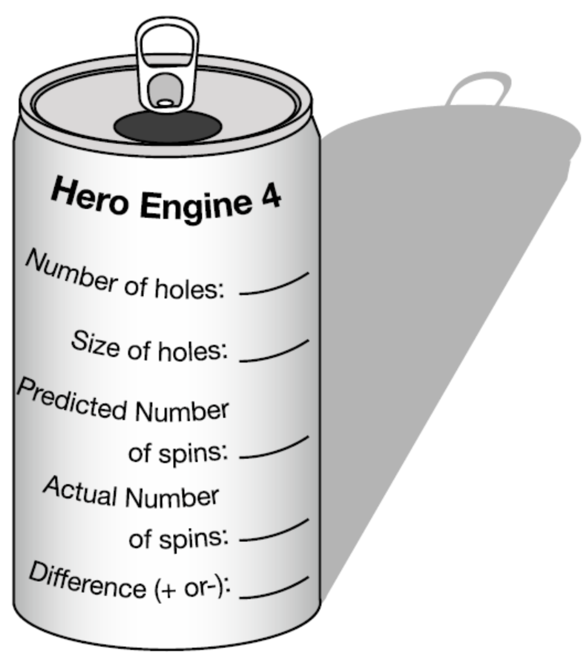
Briefly describe your new soda can engine (hole size, number of holes, placement, etc.)

Did your new soda can engine out-perform the original engines you built?

What did you learn about Newton’s laws of motion by building and testing soda can engines?

