Student Worksheet
Studying Rocks on Mars Using Light
Section 1
Different elements can be detected through the wavelength (color) of light they emit during a flame ionization test. Record your observations below from several known samples to serve as standards.
Sample element | Observations from flame ionization test

Section 2
In the case of an unknown sample on Mars, several elements are often included. Make some predictions as to what elements are contained in the unknown sample during its flame ionization test.
Sample element | Observations from sample spectra

Section 3

Instruments such as ChemCam and SuperCam on the Curiosity and Perseverance rovers use much more advanced techniques than our eyes to determine the specific wavelength of the color being emitted. Look at the spectra below of standards of pure elements to see what the rover is looking for.

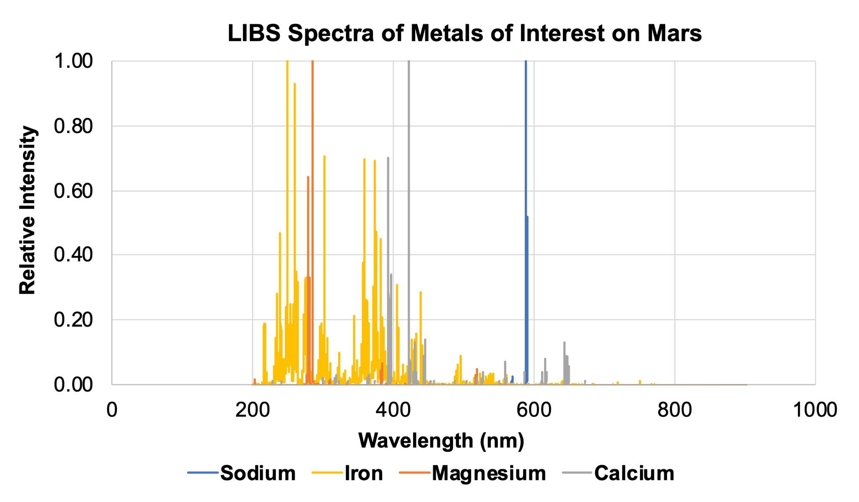

Section 4
What can you conclude about the three very similar rock structures shown below, Calcite, Dolomite, and Ankerite? What do they have in common? What elements make them unique and would allow you to tell them apart?

Write your answer here:

Note: In the graphs below, different elements show up with different relative intensities, so some peaks may not be as tall or as sharp as others. The yellow and orange highlighted areas indicate the presence of iron and magnesium, respectively.

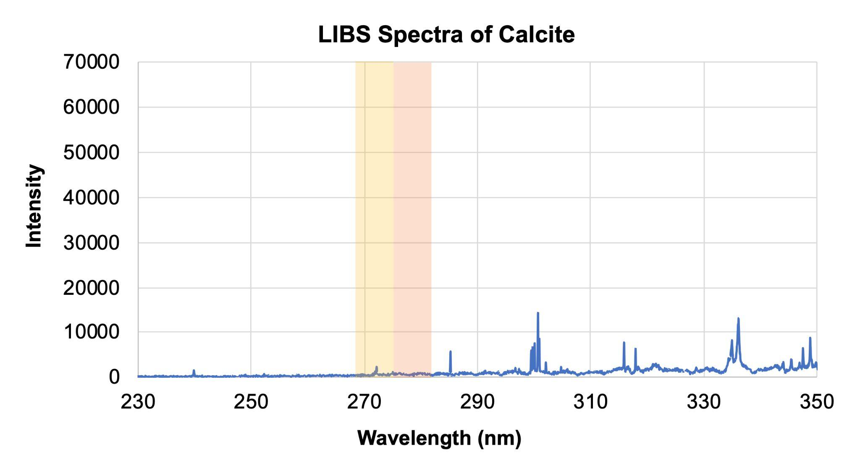

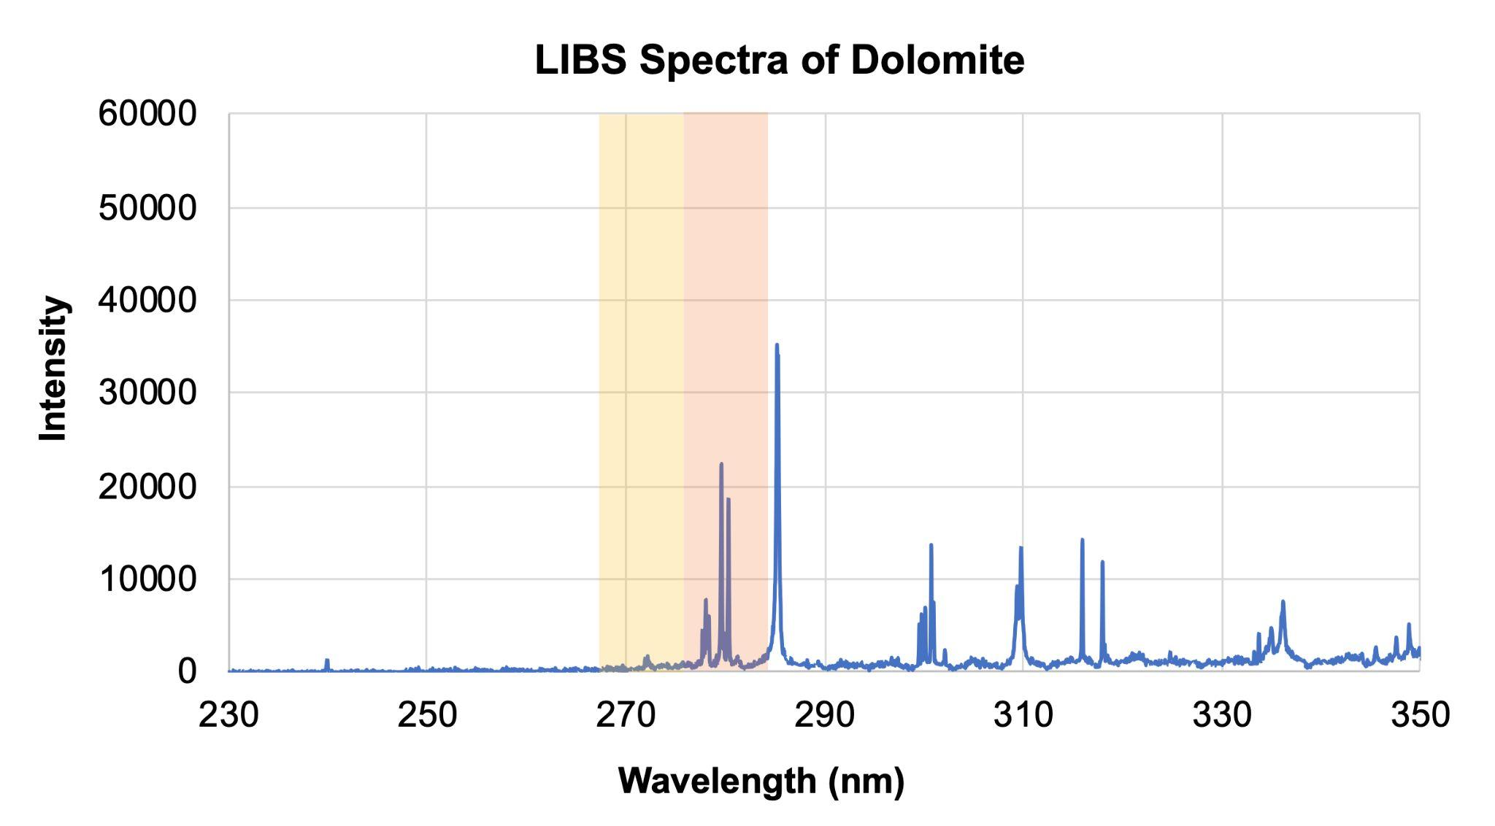

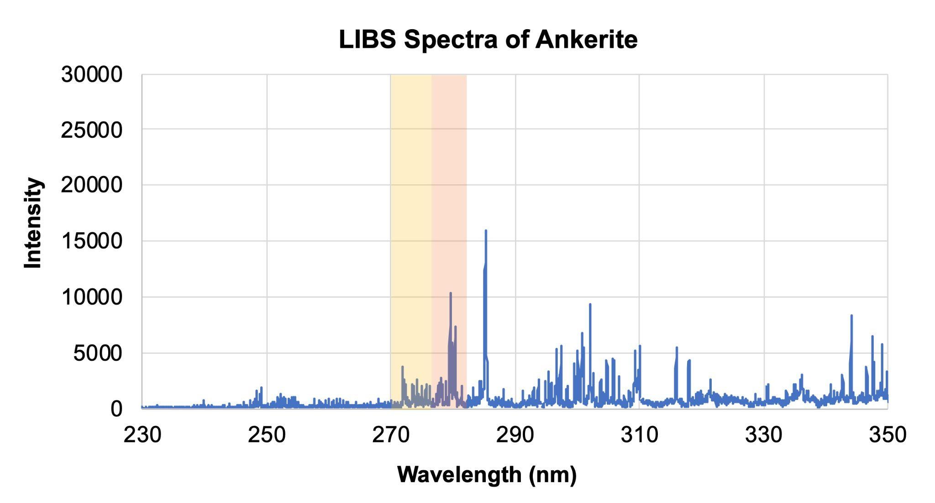

Section 5
Using the spectra of the standards, analyze the two samples below, collected by the Perseverance and Curiosity rovers on Mars. What elements can you predict are contained within each sample? Based on your analysis and what you know about the rovers' landing sites, which rover do you think collected each sample?

Write your answer here:

