Answer Key
Studying Rocks on Mars Using Light
Section 1
Different elements can be detected through the wavelength (color) of light they emit during a flame ionization test. Record your observations below from several known samples to serve as standards. Examples may include:
Sample element | Observations from flame ionization test
Copper | Bright Green
Potassium | Violet/Purple
Barium | Pale green/Yellow
Calcium | Dark orange

Section 2
In the case of an unknown sample on Mars, several elements are often included. Make some predictions as to what elements are contained in the unknown sample during its flame ionization test. Examples may include:
Sample element | Observations from sample spectra
Strontium | Bright red
Sodium | Fluffy, light orange
Boron | Bright green/Yellow
Iron | Bright yellow

Section 3

Instruments such as ChemCam and SuperCam on the Curiosity and Perseverance rovers use much more advanced techniques than our eyes to determine the specific wavelength of the color being emitted. Look at the spectra below of standards of pure elements to see what the rover is looking for.

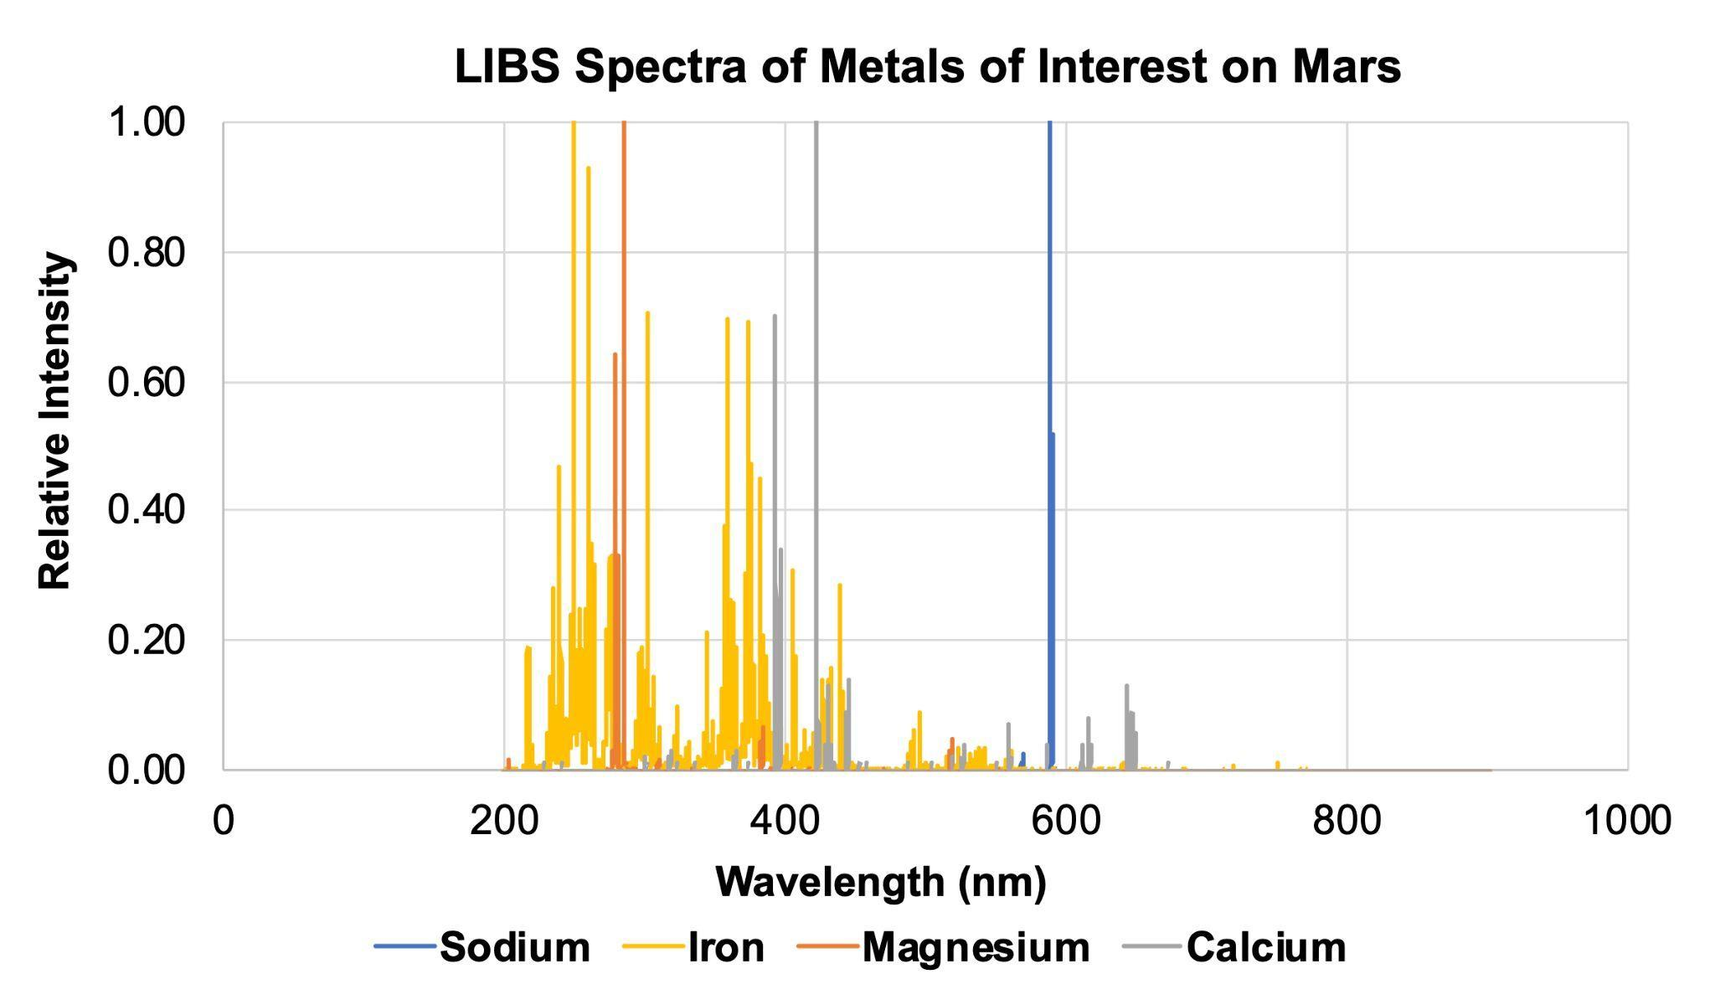

Section 4
What can you conclude about the three very similar rock structures shown below, Calcite, Dolomite, and Ankerite? What do they have in common? What elements make them unique and would allow you to tell them apart?

Write your answer here:

Calcite has little to no iron or magnesium when compared to the reference spectra in Part 3. Dolomite and Ankerite both appear to have Magnesium and Iron, with more Iron being found in the Ankerite sample.

Note: In the graphs below, different elements show up with different relative intensities, so some peaks may not be as tall or as sharp as others. The yellow and orange highlighted areas indicate the presence of iron and magnesium, respectively.

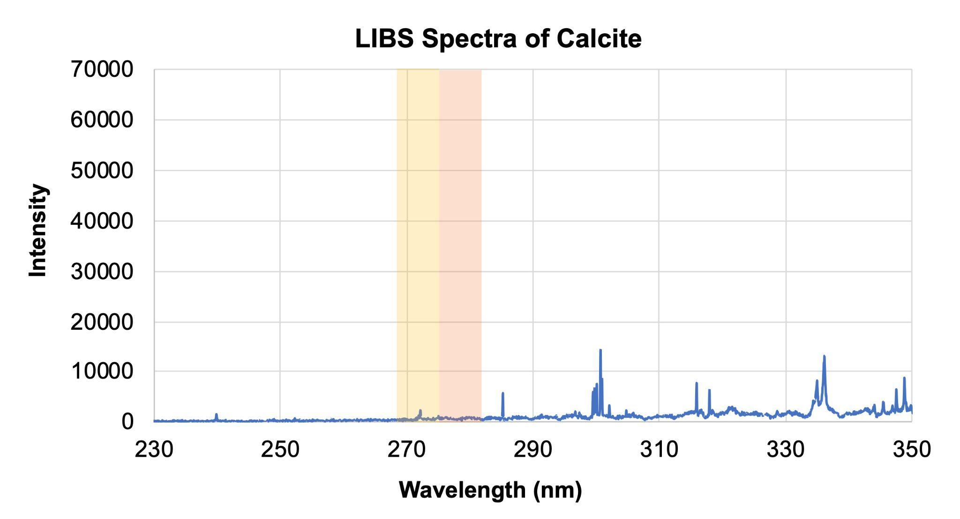

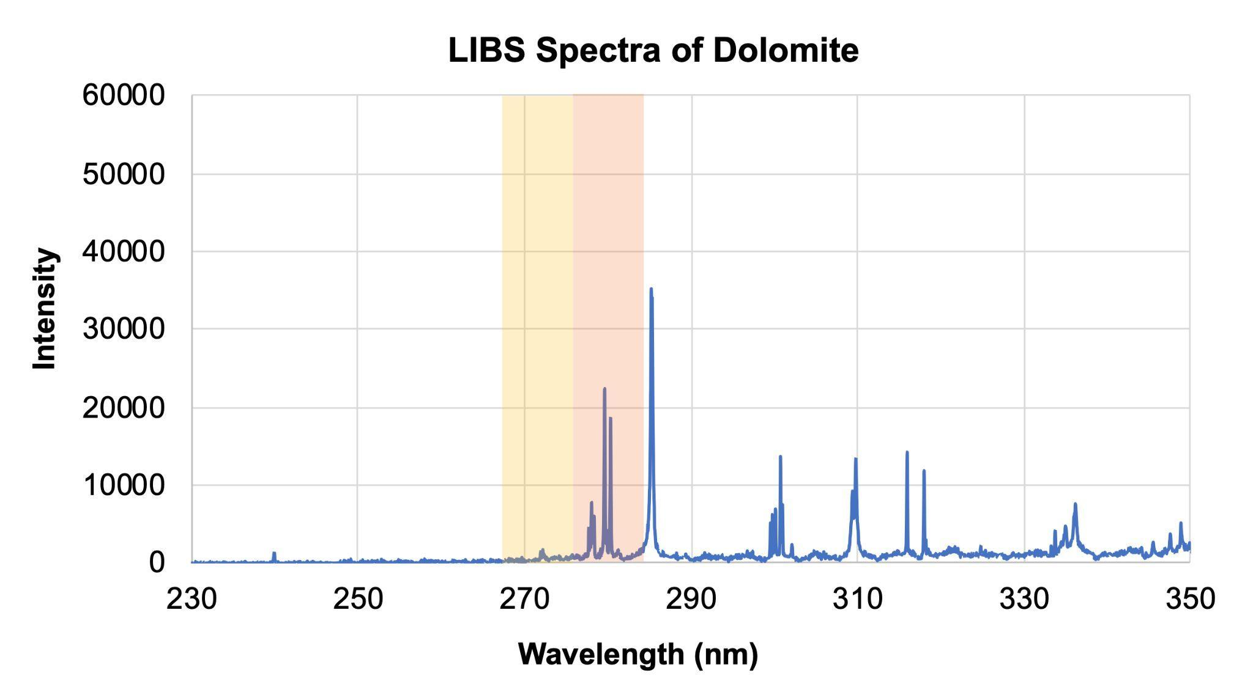

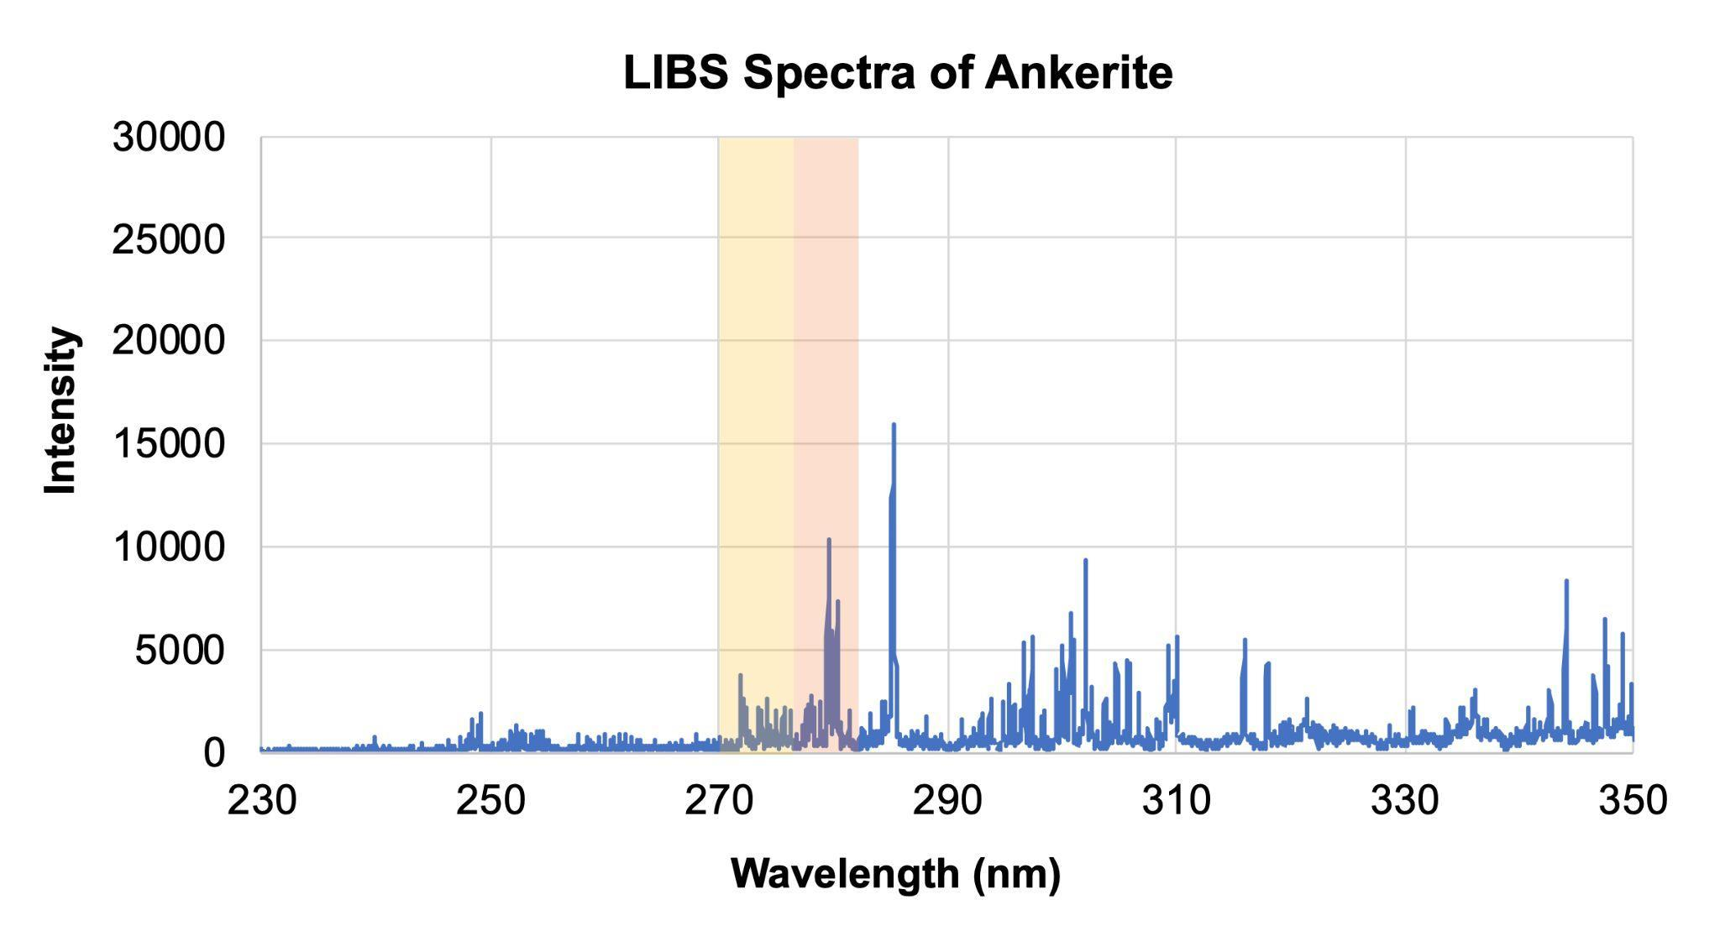

Section 5
Using the spectra of the standards, analyze the two samples below, collected by the Perseverance and Curiosity rovers on Mars. What elements can you predict are contained within each sample? Based on your analysis and what you know about the rovers' landing sites, which rover do you think collected each sample?

Write your answer here:

Both samples appear to contain iron and magnesium, so the metal cations look to be similar. However the Magnesite has a large peak at 310 nm that the Olivine does not. This corresponds to Calcium. Mageniste is a variation of calcium carbonate (CaCO₃²⁻), which is the family of rocks we expect to find at Jezero Crater. Olivine contains silicon, which is likely the peak at 285 nm. Olivine is a silicate (SiO₄²⁻), and silicates have been found at Gale crater.

