ANSWER KEY
Modeling Crustal Folds
Note: This is a sample answer key. Student models and sketches will vary.
Representing Crustal Deformation and Faults
- Syncline and Anticline: Take your block and apply pressure inward from the left and right sides. Your block should look like it has “waves”. Trim a thin, 1 cm layer off the top of your block with your knife to represent erosion, exposing the rock below. Draw your block below, being sure to have layers on each side of the block identified. Indicate where your axis or hinge line is for your syncline and anticline. Knowing that the oldest rock is deposited first and younger layers are on top, can you tell where the oldest rock is exposed?
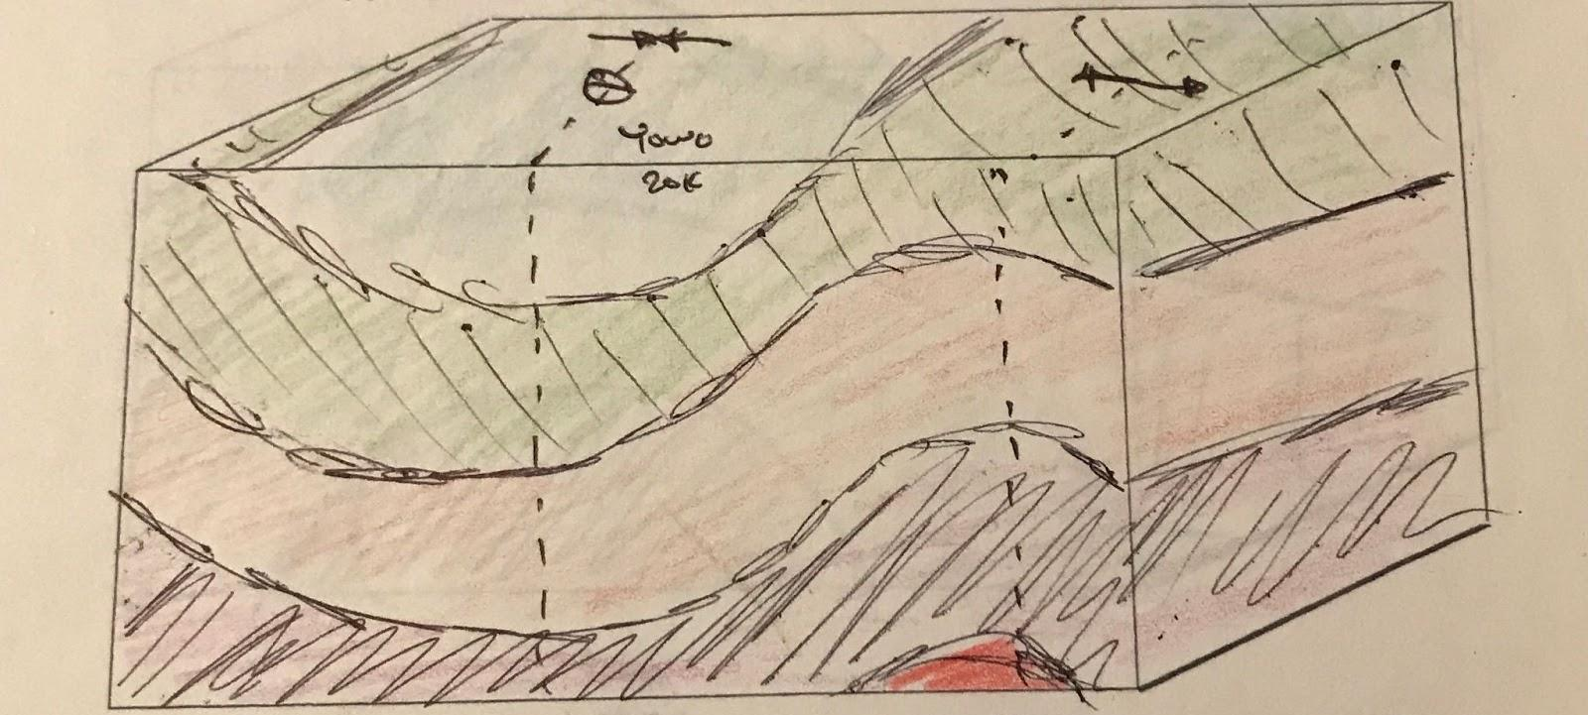
- Plunging Synclines and Anticlines: Tilt your block from (1) towards you, and use the plastic knife to make another cut. Your block was at an angle, so the front will now no longer be the same width as the back of your block. Because of the “plunge” of the block, the rock below is exposed at different angles. Draw your block below.
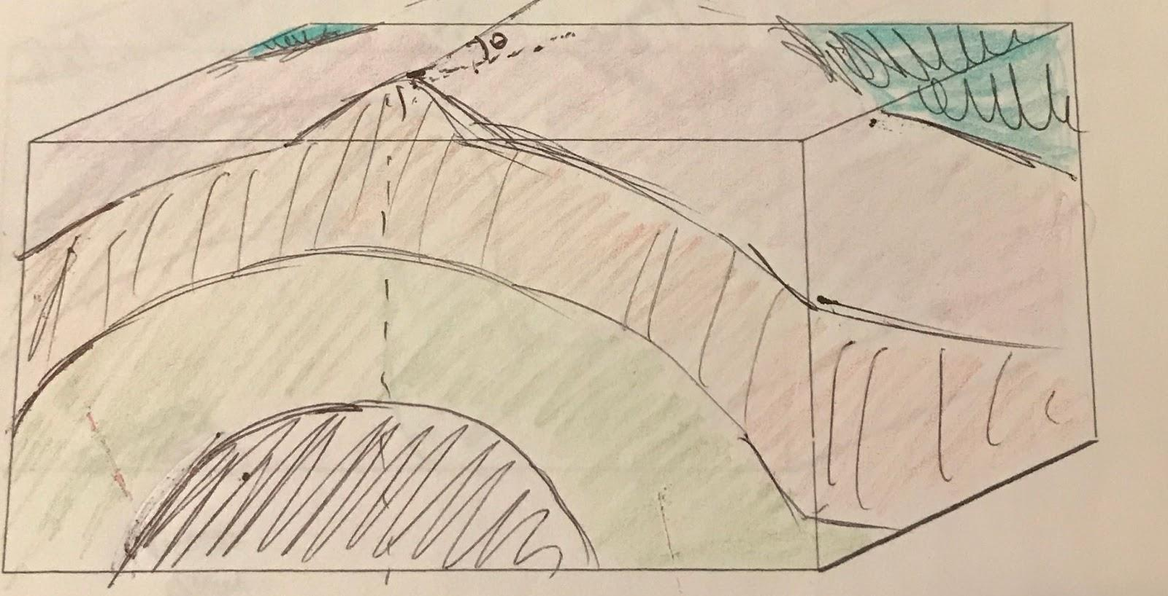
- Asymmetrical Folds: In the real world, the compression of Earth’s crust rarely makes nice, even folds. Represent a more realistic fold by preparing a fresh block with your play dough, and now try to compress your layers from the sides like in (1). But this time, have the folds leaning more to one side than the other. Just as we did before, “erode” away the top cm with your knife. How does this block differ from (1) and (2)? How could you tell from the view above that there was an asymmetrical fold hidden beneath?
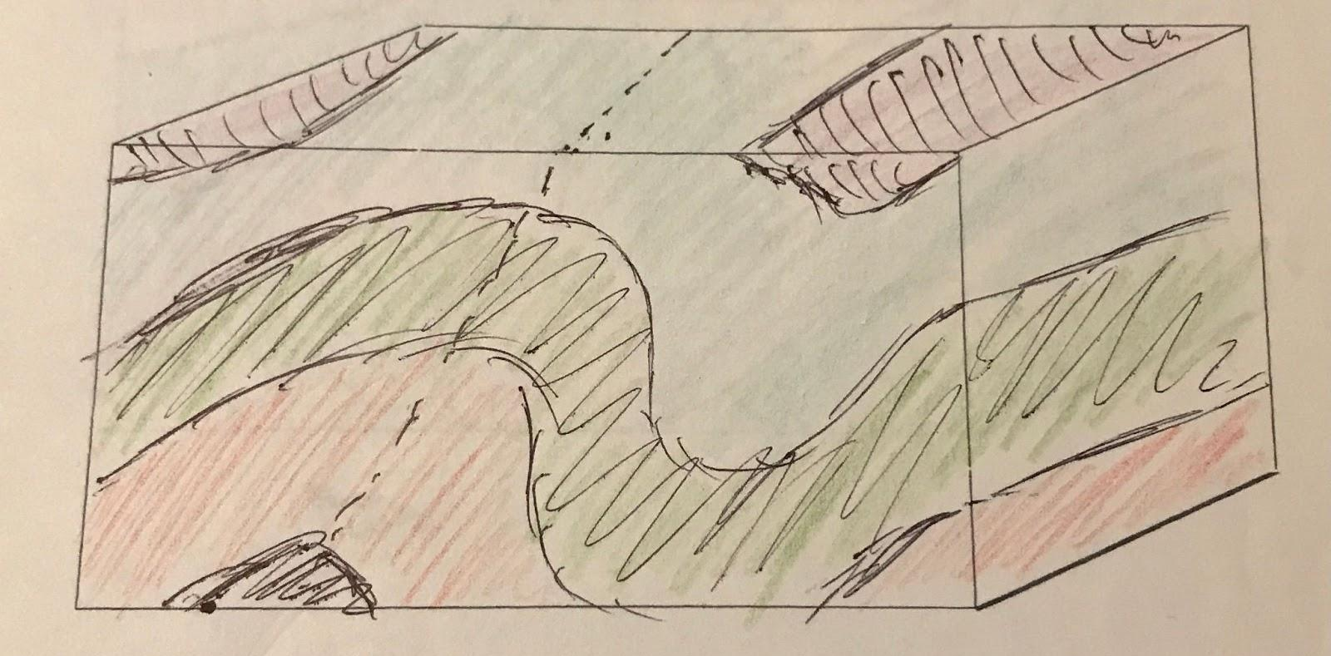
- Faults: Lastly, cut your block from top to bottom at an angle of your choosing. “Slide” one side of the block up or down so that one side of the block is above the other. You’ve just simulated a type of earthquake! As before, use your knife to “erode” the top cm or so to even out both sides of the block. Draw your block below. From your observations, how does erosion tell us about the presence of faults?
