STUDENT WORKSHEET

Math of the Expanding Universe
Unlike light leaving the Sun, which takes 8.5 minutes to reach Earth, light leaving distant stars and galaxies can take billions of years to reach our planet. As they travel, the waves that make up the light get stretched as the universe expands – something it’s been doing since the Big Bang.
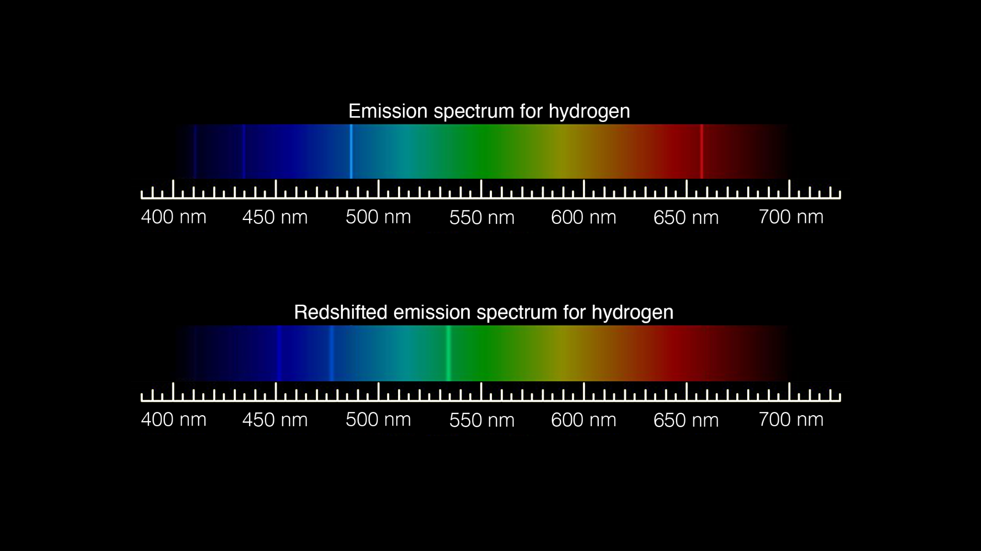
What this means for light coming from distant galaxies is that the visible lightwaves you would be able to see with your eyes get stretched into longer wavelengths and shift from visible light toward infrared. Scientists refer to this phenomenon as redshift – and the farther away an object is, the more redshift it undergoes.
Notice how the bright lines on the standard emission spectrum for hydrogen (top) have moved toward the red end of the spectrum on the redshifted emission spectrum (bottom). Image credit: NASA/JPL-Caltech
Using the equations and data below, calculate the redshift of supernova iPTF15th, its velocity, and its distance away from Earth.

Calculate redshift
- Use the redshift equation and the information from the spectra for supernova iPTF15th below to find z for one of the spectral lines.
z = (Wavelength_{o} - Wavelength_{r}) / Wavelength_{r}
z = redshift
Wavelength_{o} = the observed wavelength of that spectral line.
Wavelength_{r} = the known wavelength of an element at rest (not moving)

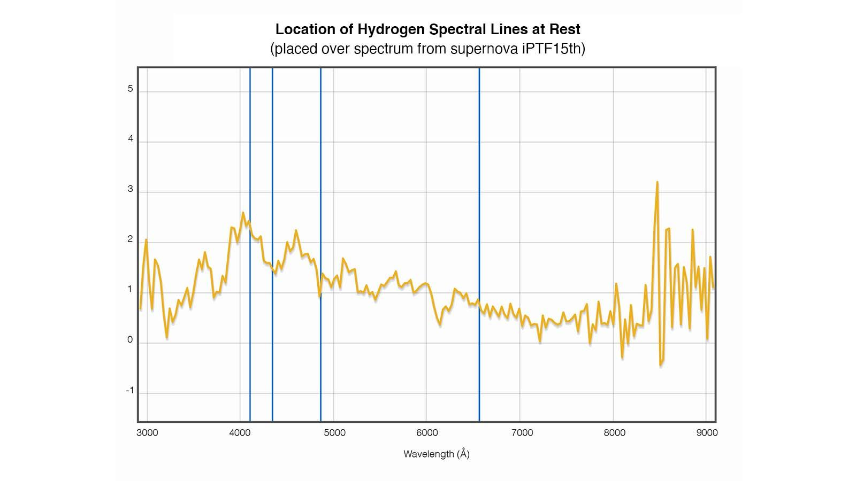
This is the spectrum of supernova iPTF15th. The blue lines represent the location of hydrogen spectral lines at rest.
Location of Hydrogen Spectral Lines Observed (in spectrum from supernova iPTF15th). Image credit: WISeREP (2012PASP..124..668Y)

Location of hydrogen spectral lines at rest:
- Line 1: 410.2 nm
- Line 2: 434.0 nm
- Line 3: 486.1 nm
- Line 4: 656.3 nm

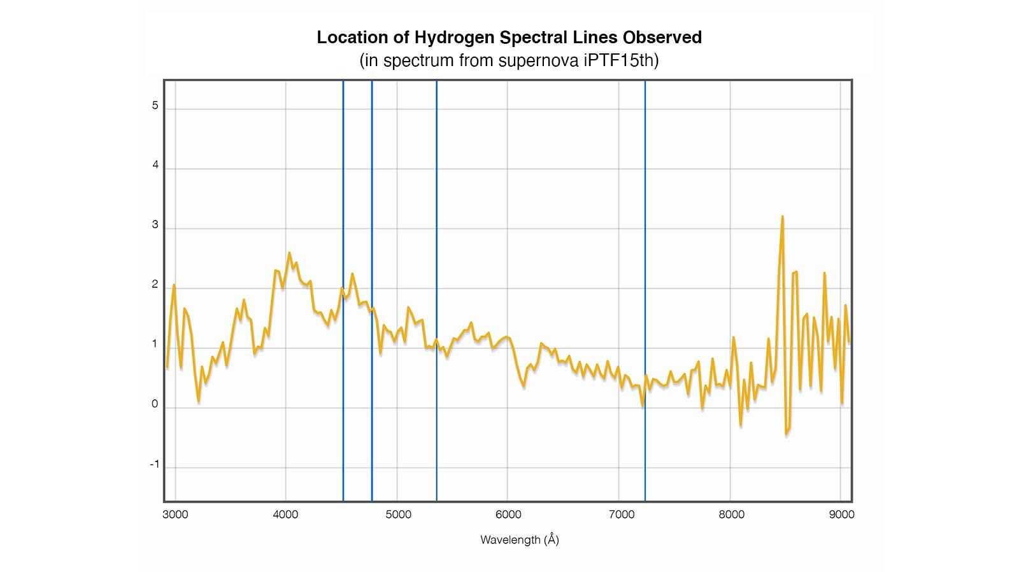
This is the same spectrum, but the blue lines are located where the redshifted hydrogen spectral lines were observed.
Location of Hydrogen Spectral Lines at Rest (placed over spectrum from supernova iPTF15th). Image credit: WISeREP (2012PASP..124..668Y)
Location of hydrogen spectral lines observed in spectrum from supernova iPTF15th:
- Line 1: 4511.91 Å
- Line 2: 4773.69 Å
- Line 3: 5347.64 Å
- Line 4: 7219.33 Å

z = ____________

Calculate velocity
- Use the Doppler shift equation below to calculate the velocity of supernova iPTF15th away from Earth.
((wavelength_{o} - wavelength_{r}) / wavelength_{r}) = v / c
Speed of light (c) = 3 x 10⁸ m/sec
v = velocity

v = _______________

Calculate distance
- Use Hubble’s Law, which is the observation that galaxies are moving away from Earth at speeds proportional to their distance (d), to calculate the distance to supernova iPTF15th.
v = H₀ * d
H₀ = the Hubble constant of approximately 70 km/sec/Megaparsec
d = distance from Earth

A parsec is a unit of distance equal to approximately 3.26 light years, and a Megaparsec is equal to one million parsecs.

d = ___________________

